

National Textile University
Department of Computer Science

Subject:

Mobile Application Development

Submitted to:

Sir Rehan Sarwar

Submitted by:

Eemaan Fatima

Reg. number:

23-NTU-CS-FL-1146

Semester:
6th - A

Lab 03 :

Q1:
Task 1: Custom Cards and Icon Layouts Objective: Master the Card widget's visual properties and child arrangement.
• Activity: Create three Card widgets with varying color properties and elevation values.
• Requirement: Each card must contain a Row or Column of multiple Icon widgets with different sizes and colors.
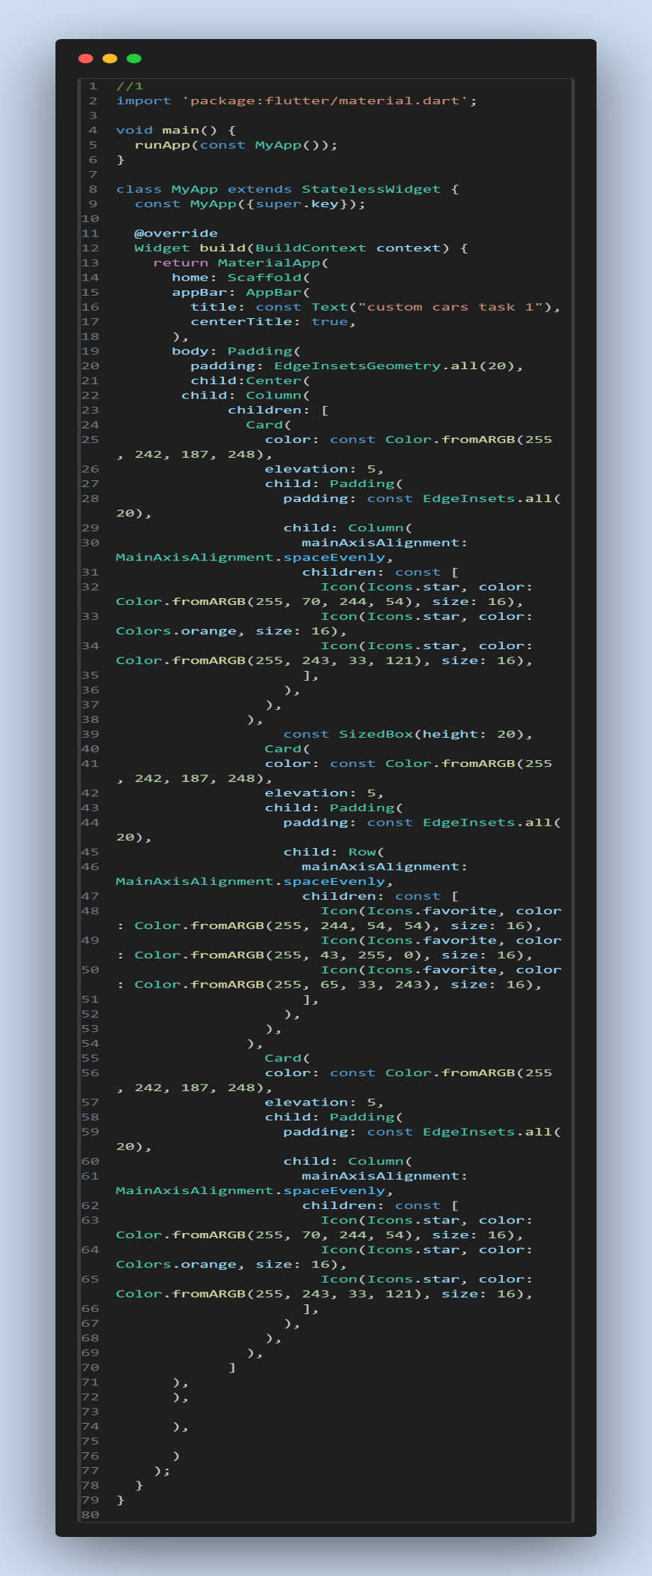
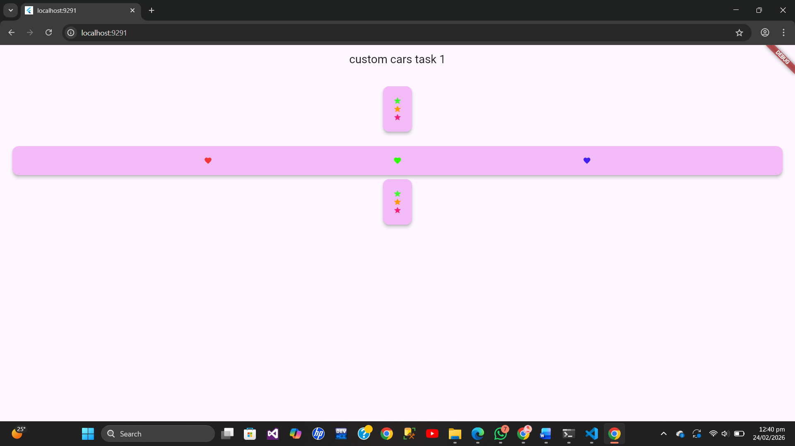

Q2:

Task 2: Margin and Padding Implementation Objective: Differentiate between internal (Padding) and external (Margin) spacing.
• Activity: Create a Container with a background color and implement the following:
o All sides: Use padding: EdgeInsets.all(20.0).
o Symmetric: Use margin: EdgeInsets.symmetric(vertical: 50.0, horizontal: 10.0).
o Specific sides: Use EdgeInsets.only(left: 10) to add space only to the left.
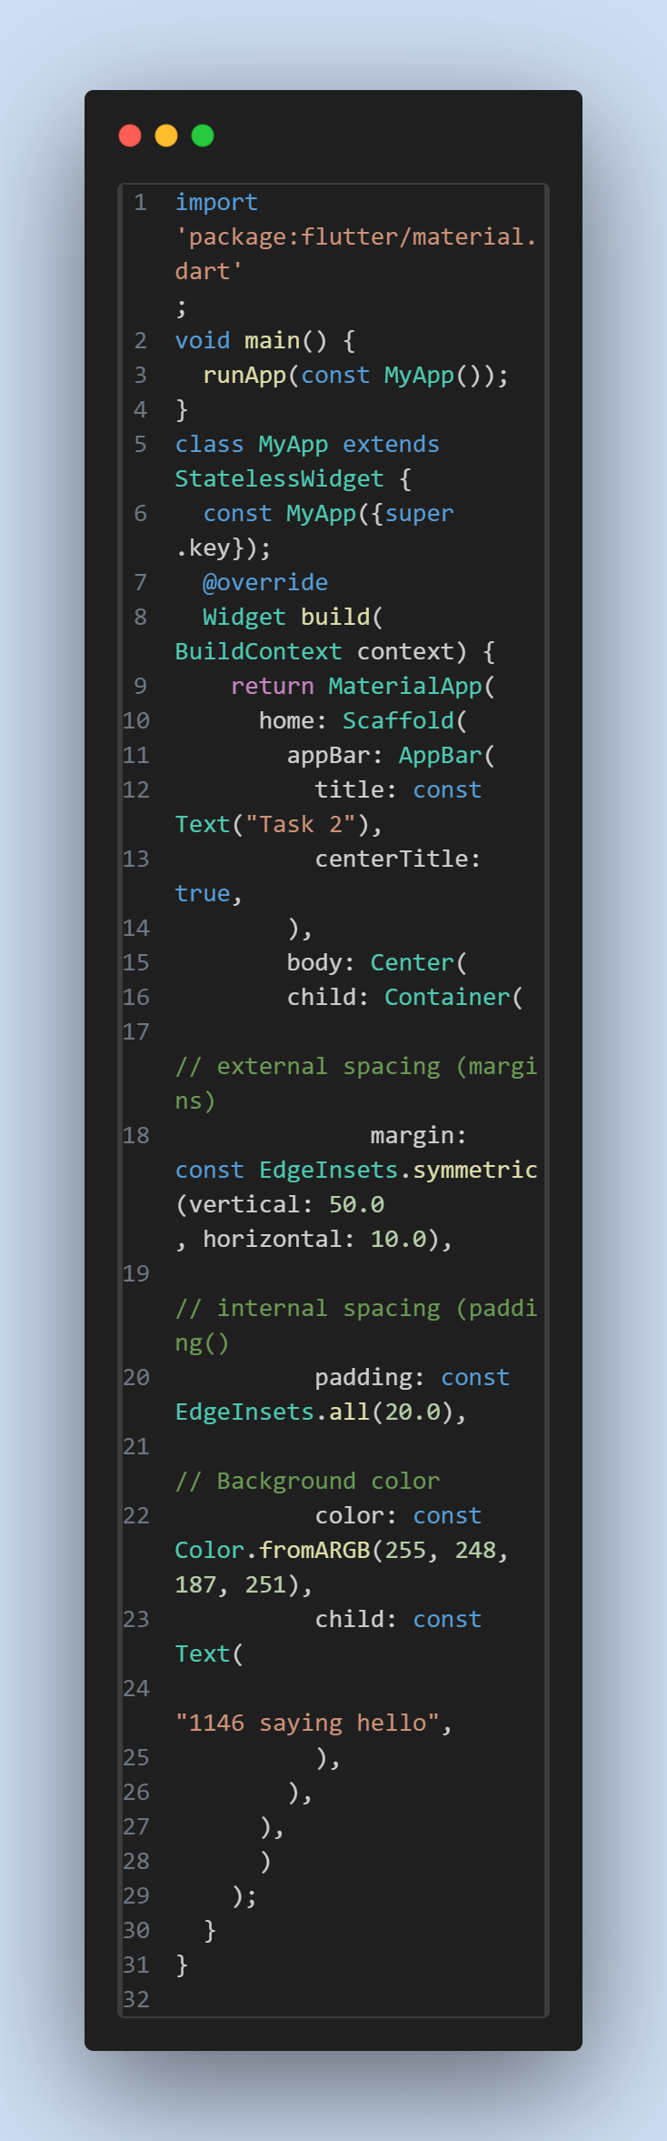

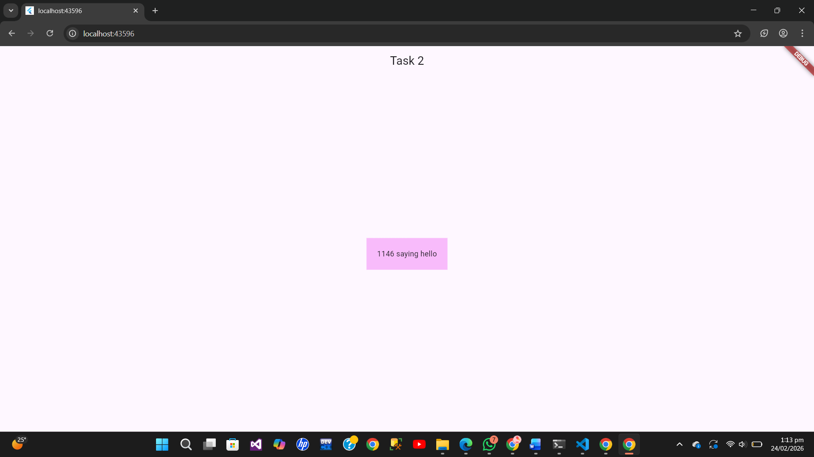

Q 3:
Task 3: Profile UI with CircleAvatar Objective: Implement user identity visuals in different UI areas.
• Activity:
1. Place a CircleAvatar in the body that loads a profile image via NetworkImage.
2. Place a second CircleAvatar within the AppBar (typically in the actions or leading property) using AssetImage for a local file.
• Requirement: Ensure the avatar correctly represents a user profile or initials if the image fails to load.
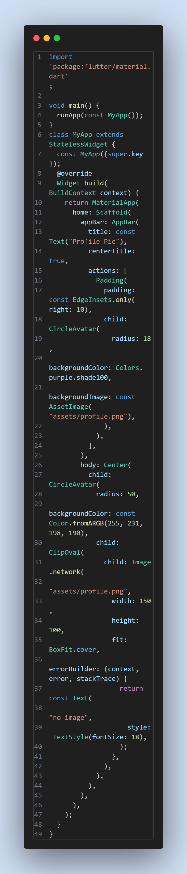
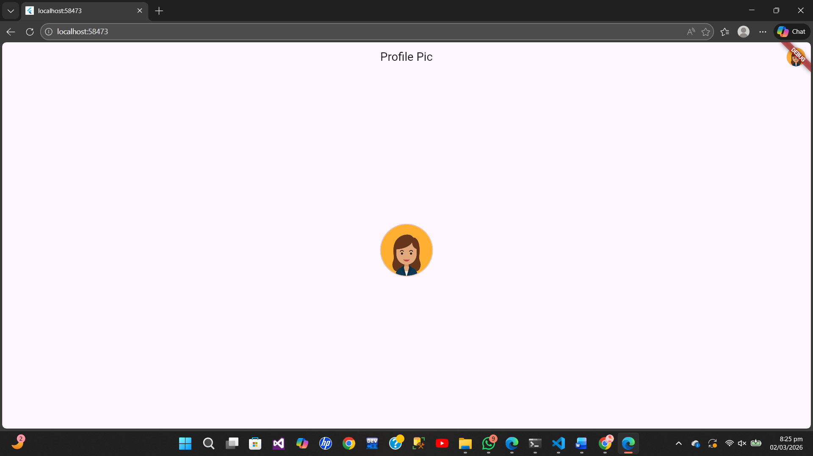

Q 4:
Information Grouping with Card & ListTile Objective: Use ListTile to create structured, repeatable UI elements.
• Activity: 1. Create a Card with rounded corners and an elevation shadow.
2. Inside the Card, nest a ListTile.
• Requirement: o Leading:
Use an Icon or CircleAvatar.
o Title: Contact name.
o Subtitle: Registration No.
o Variations: Create a second version with a different color scheme and a trailing icon.
